**4.Create a simple cloud software application for Car Booking Reservation System using any Cloud Service Provider to demonstrate SaaS**.

**Aim**

The aim of this project is to create a simple cloud-based Car Booking Reservation System using a cloud service provider, demonstrating the SaaS model where users can access the application online to book cars and manage reservations.

**Procedure**

1. Selected Zoho Creator as the cloud platform.
2. Created a new application named *Car Booking Reservation System*.
3. Designed two forms: Car Details (car model, type, price, availability) and Booking (customer, car lookup, pickup/drop-off date-time, total amount, status).
4. Added a formula field to automatically calculate the total amount based on rental duration and car price.
5. Configured workflows to update car availability when bookings are made or cancelled.
6. Created reports/views for Available Cars, My Bookings, and Admin Dashboard.
7. Deployed and tested the application with sample data.

OUTPUT :

CAR DETAILS:

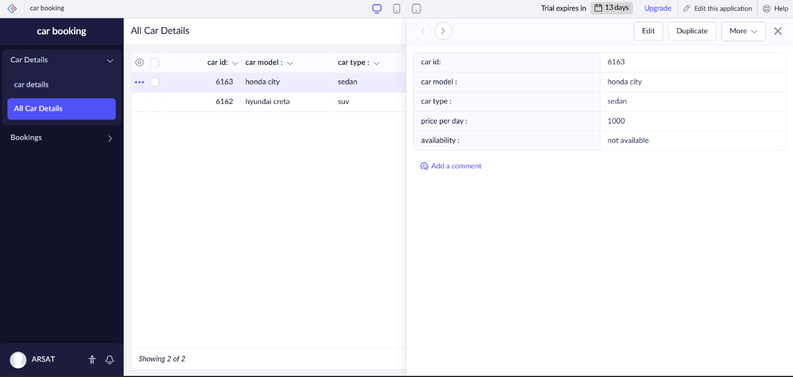

BOOKING DETAILS:

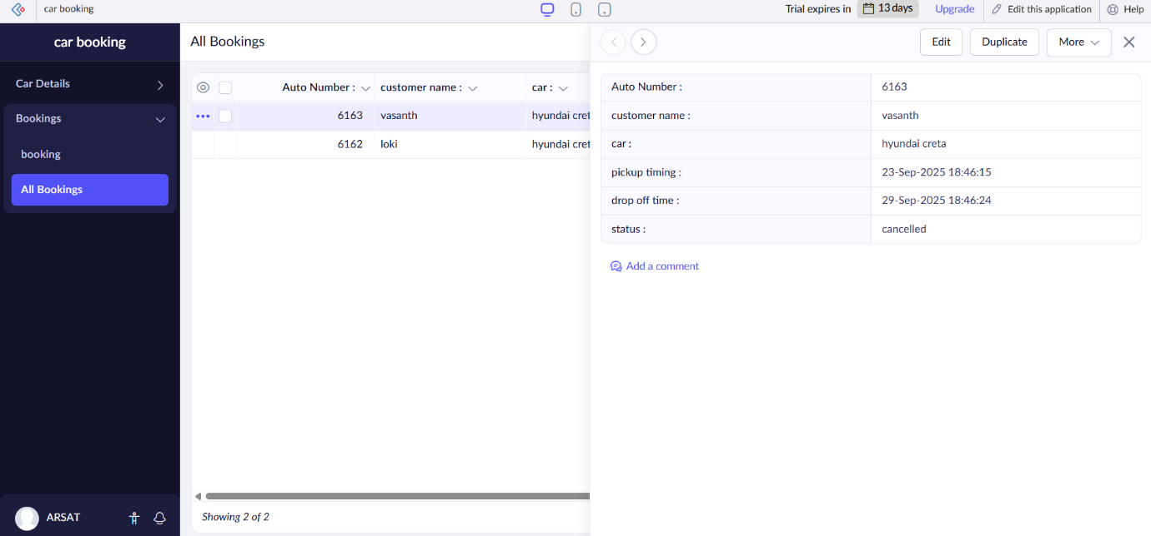

**Result**

A functional cloud-based Car Booking Reservation System was successfully developed and deployed. The system allowed users to book cars, view availability, and see the total rental cost calculated automatically, while administrators could manage bookings and cars effectively, showcasing the SaaS model in action.